**CSC 371/471 Mobile Application Development (iOS)**

**Final Project Proposal- Winter 2021**

**Design and Implement an iOS App**

**Project title:**

Road Runners Water Stop

**Indicate either:**

This is an Individual project.

**Individual Project by:**

Jessica Bender

**Project Description:** What will your app do? What are the main features or functions?

This app will allow users who are part of the road runners running group to sign up and volunteer to provide water for the club’s weekly practices.

The home I want to have a glass that will fill as you do water stops as you do more water stops. Once your glass is full you get your entry to the half-marathon for free. (I will have to see if the water thing is possible though)

This app will also allow users to add when a show is going live onto their calendar, so they don’t miss it! Also, looking at signing in with google.

**Preliminary Screen Design:** Describe each screen and include drawings of each screen. Hand-drawn diagrams are acceptable.

*These are very rough designs so I apologize in advance.*

Screen 1:

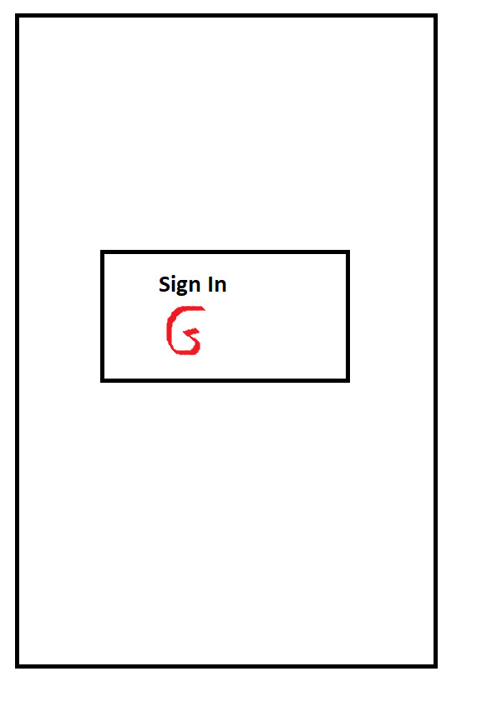

Screen 2:

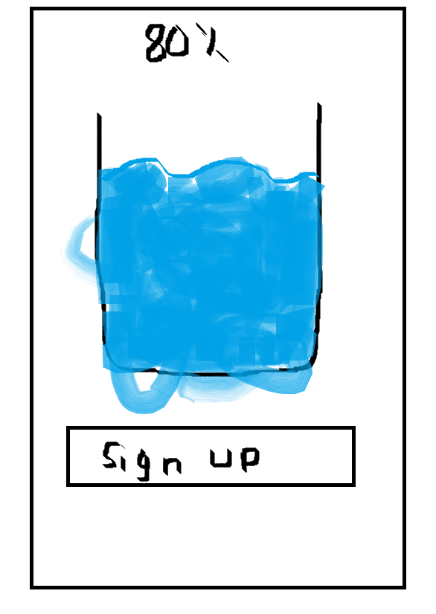

Screen 3:

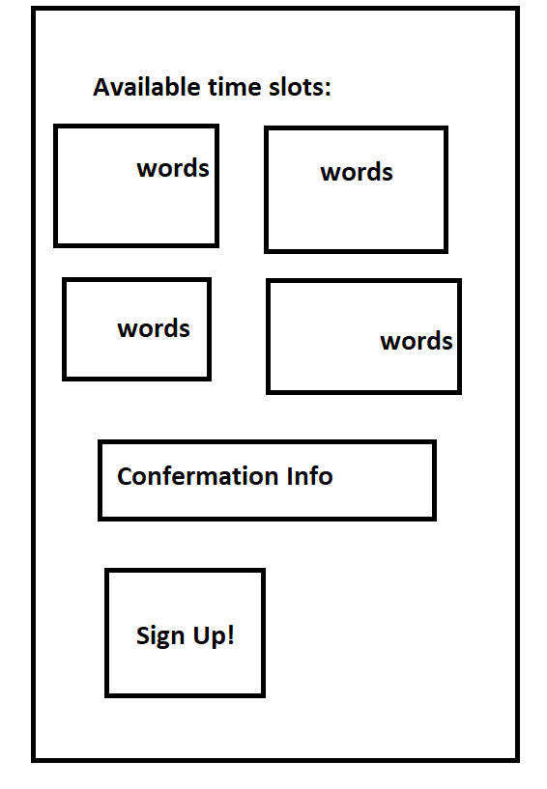

Screen 4:

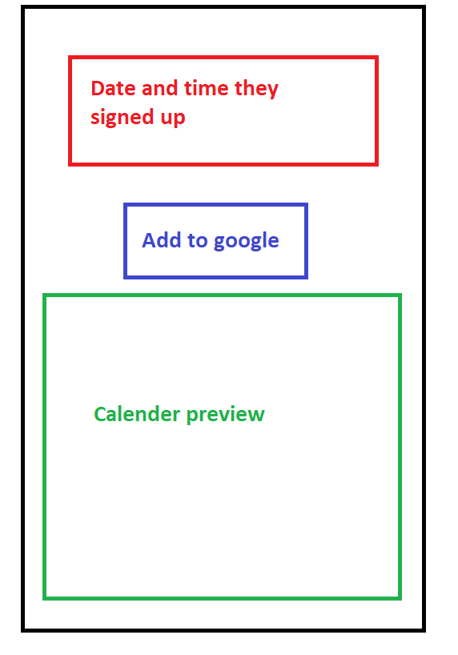

**API Features (might)Used:**

Google Calender: <https://developers.google.com/calendar>

Google Sheets: <https://developers.google.com/sheets/api>

Google Identity <https://developers.google.com/identity>